Ruta: https://pdt-canyon-exp-acute.trycloudflare.com/settings/group-kinds
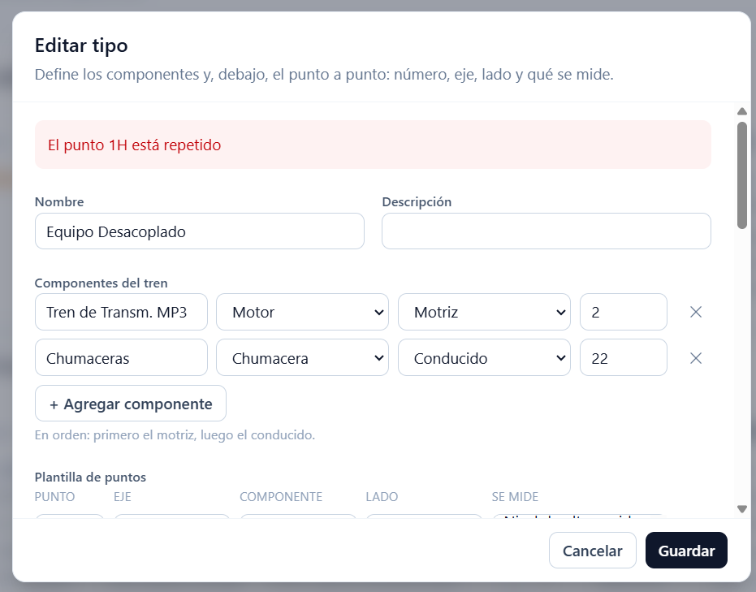

Ruta: https://pdt-canyon-exp-acute.trycloudflare.com/measurements/3
- Velocidad mm/s RMS.
- Aceleración gEs RMS
- Envolvente Aceleración gE RMS.
- Temperatura
Ruta: https://pdt-canyon-exp-acute.trycloudflare.com/settings/group-kinds
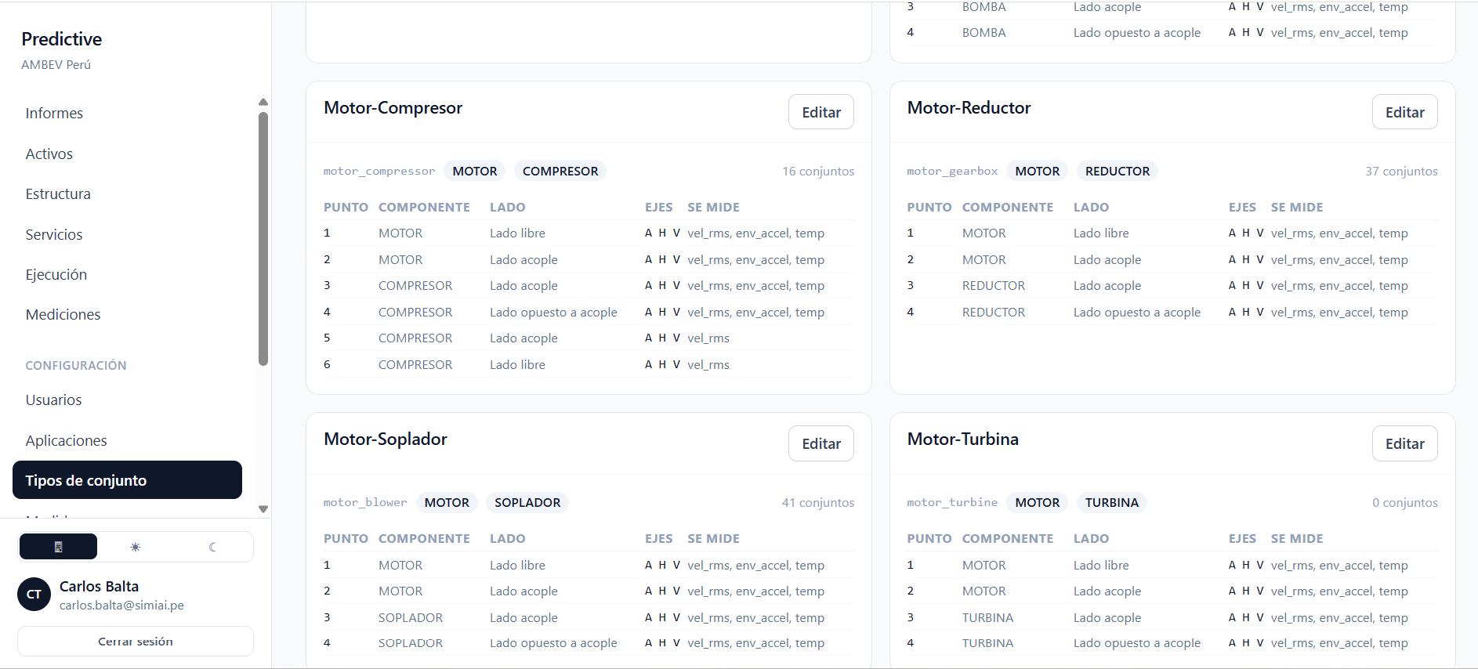

Ruta: https://pdt-canyon-exp-acute.trycloudflare.com/services/visits/4328
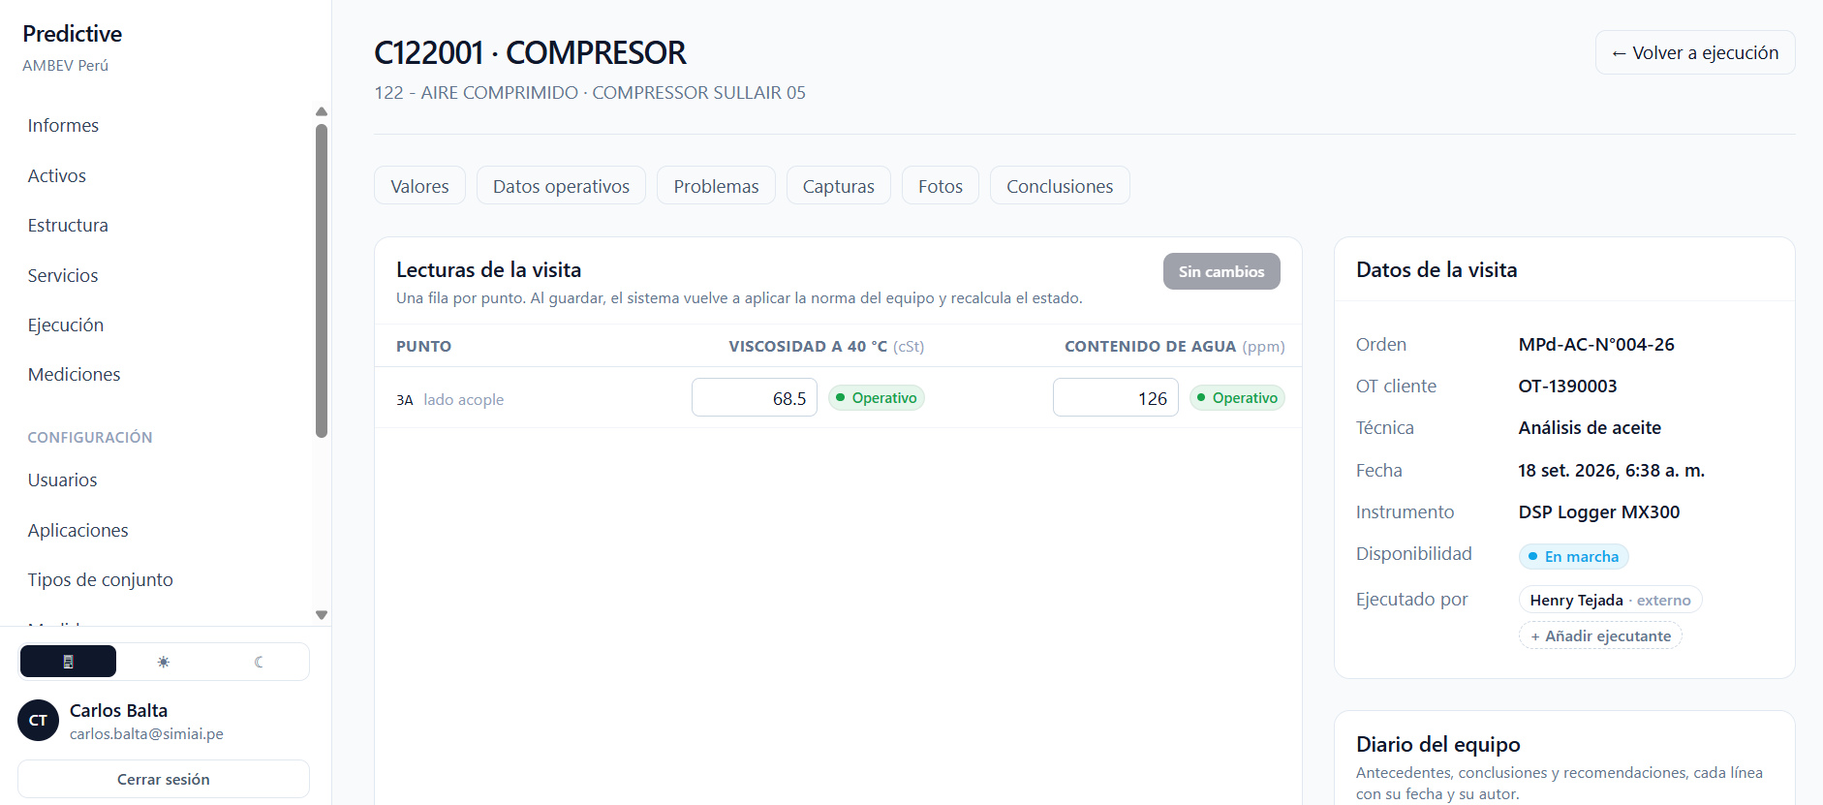

Ruta: https://pdt-canyon-exp-acute.trycloudflare.com/services/visits/4328#operating
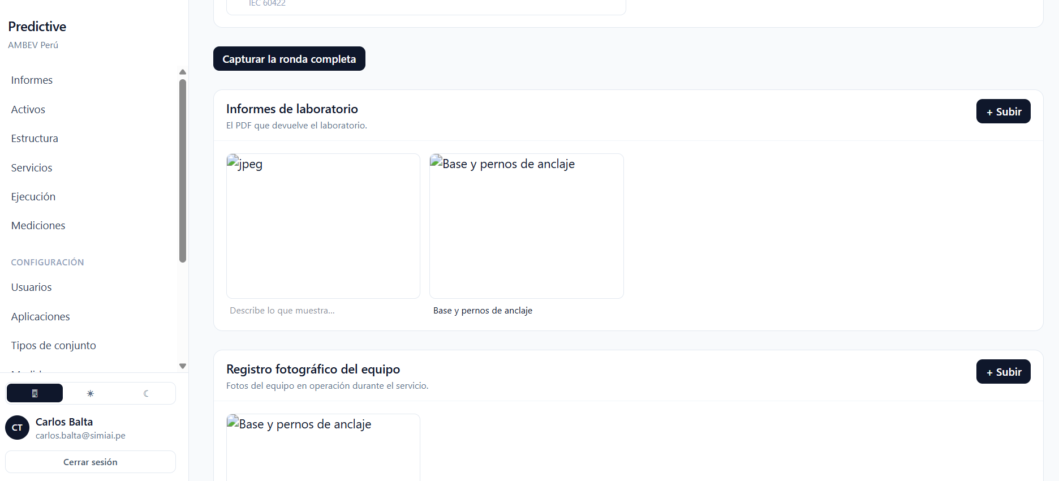

Ruta: https://pdt-canyon-exp-acute.trycloudflare.com/services
